# 

# Move existing files from F drive to OneDrive

Note: you will need to be connected to a Citrix VDI or the AnyConnect VPN on your laptop to access the F drive to move files. Once files are moved to OneDrive, you will no longer need that connection to access your files if you are on a company approved device.

**Pro tip: Take this opportunity to do some clean up! Spend some time evaluating what files you want to bring forward and what files can be left behind and archived.**

How do I access OneDrive?

There are many ways to access OneDrive. You can also access it on any company joined mobile device like an iPad or iPhone.

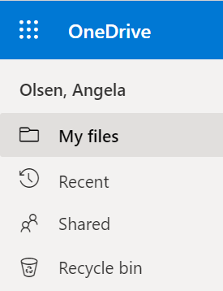**Web version**

* Open the Edge browser and go to [auth.azblue.com](https://auth.azblue.com/login/default). This is the Okta authentication landing page. Here you will find all apps that are accessible without connecting to the VPN.
* Find OneDrive on the page or use the search bar on top and select it. It will open in a new tab.

**File Explorer**

* Find File Explorer pinned to your taskbar or type it in the search box.
* 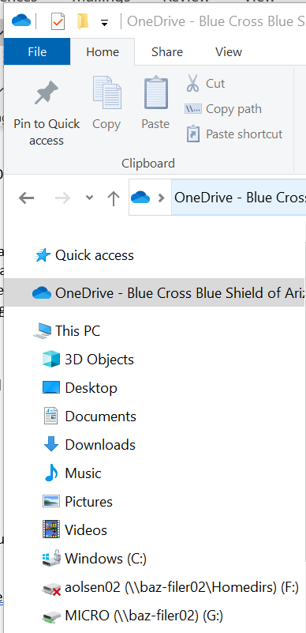You will find OneDrive just below Quick access and above your network drives.

**Inside Teams**

* Select the Files tab in Teams, on the left menu.

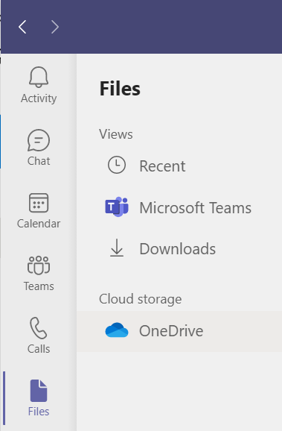

**Saving in Office apps**

* You may have noticed, after the Office upgrade, that saving your files to the cloud are the first options you see.

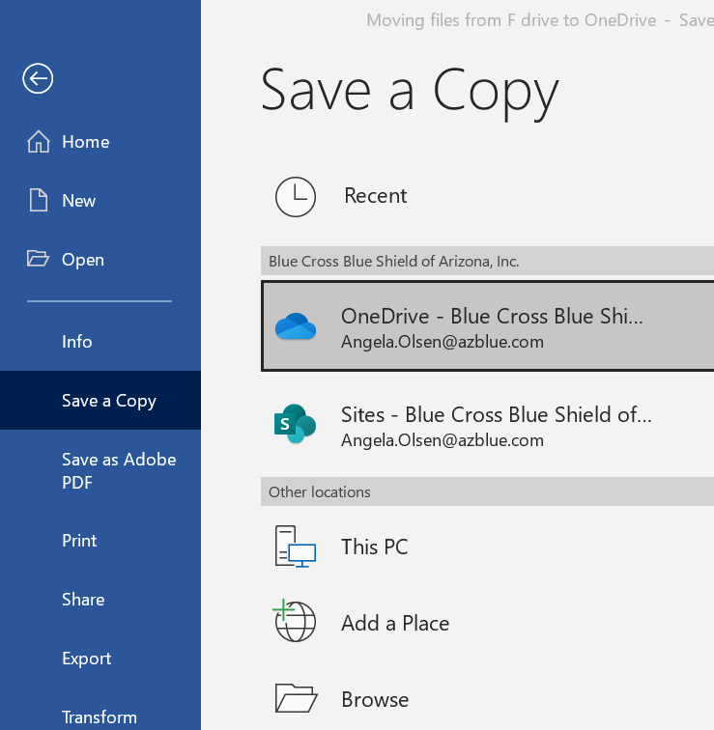

Save to OneDrive

Save to a Team channel or SharePoint site

How do I move my files to OneDrive?

In the Microsoft 365 world there is always more than one way to accomplish a task. Here are two recommended ways to move your files, but there are also others you might discover.

**Note: There are some file name and file type restrictions and/or limitations in OneDrive. If you are having trouble moving a file or getting a sync error,** [**check out this support article**](https://support.microsoft.com/en-us/office/restrictions-and-limitations-in-onedrive-and-sharepoint-64883a5d-228e-48f5-b3d2-eb39e07630fa) **for help.**

**Use File Explorer and the web version of OneDrive**

1. Open OneDrive as described above. One instance in a web browser and another instance in File Explorer.
2. From here, you can simply drag and drop files from File Explorer to OneDrive on the web.

**Use two instances of File Explorer at the same time**

1. Open two instances of File Explorer. In one, open your F drive. In the other, find OneDrive as described above.
2. Put the windows side by side and drag files from your F drive to the OneDrive folder.

**Self-help & training resources**

* [Microsoft 365 Training portal](https://support.microsoft.com/en-us/training): Find videos, templates, quick start guides and more for all the Office apps, including OneDrive, as well as Word, Excel, PowerPoint, OneNote, SharePoint, and Teams.
* [Office Quick Start Guides](https://support.microsoft.com/en-us/office/office-quick-starts-25f909da-3e76-443d-94f4-6cdf7dedc51e?wt.mc_id=otc_home): Get up and running quickly with the basic info you need to be productive right away.
* [BCBSAZ Adobe Learning Management System (LMS)](https://captivateprime.adobe.com/bluecrossblueshieldofarizonainc): Use the search bar on top to find available instructor led classes for most Office apps, including SharePoint, Excel, PowerPoint and Teams.
* 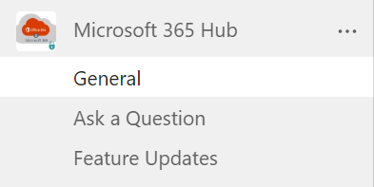[Microsoft 365 Hub in Teams](https://teams.microsoft.com/l/team/19%3a0f7947de6a124a92834f1bace8648518%40thread.tacv2/conversations?groupId=ad6c768f-1639-4cf9-8a2a-f98b42e2acf2&tenantId=14c47b18-fc55-4da5-98f0-1f17e206cadc): Join this new Public Team in Teams! Ask a question, share best practices with your peers, and learn about feature updates.

**Get assistance**

If you have questions or experience any issues, please contact the Service Desk:

* Call: **602-864-4099**
* Submit a ticket online: [Serving Blue](https://bcbsaz.service-now.com/servingblue?id=sc_cat_item&sys_id=906528a10a0a0bf000a85bc20dfb6541)
* Chat: [Serving Blue](https://bcbsaz.service-now.com/servingblue), lower right corner, **Service Desk Chat**